EDF Schdueler in RTOs

2022

[You can add an abstract or other key statement here. An abstract is typically a short summary of the document content.]

Egypt FWD 2022

Advanced Embedded   
Track  
RTOS Project

Contents

Tasks Exe. Time 1

Check System Shedulability using Time Analysis 2

System validation using Simso offline simulator 16

Notes 20

Independent Auditor’s Report 21

Contact Information 22

Company Information 22

# Tasks Exe. Time

## usinG Trace Macros and Digital Analyzer

Load1 Sim. Task exe = 5ms.

Load2 Sim. Task exe = 12 ms.

Button1 Monitor Task = 16 us

Button2 Monitor Task = 16 us

Transmitter Task = 23 us.

UART Task = 18 us.

## System HyperPeriod

LCM[All Tasks Periods]=LCM[10,100,50,50,100,20]=100 ms.

## CPU Load

CPU Load= ∑Task Exe. Time = 5*10+12*1+0.016*2+0.016*2+0.023+0.018*5 = 62.18%

Hyper Period 100

## Check system schedulability using URM

U = ∑ Ti /Pi  = 5/10+12/100+0.016/50+0.016/50+0.023/100+0.018/20 = 0.6218 < 1.

URM = 6*(21/6 -1)=1.559.

U < URM  🡺 System is schedulable using RM.

CHECK SYSTEM SCHEDULABILITY USING TIME-DEMAND ANALYSIS

# Check System Shedulability using Time Analysis

Implementation :I have created Function to calculate Time analysis for tasks and send it to uart .

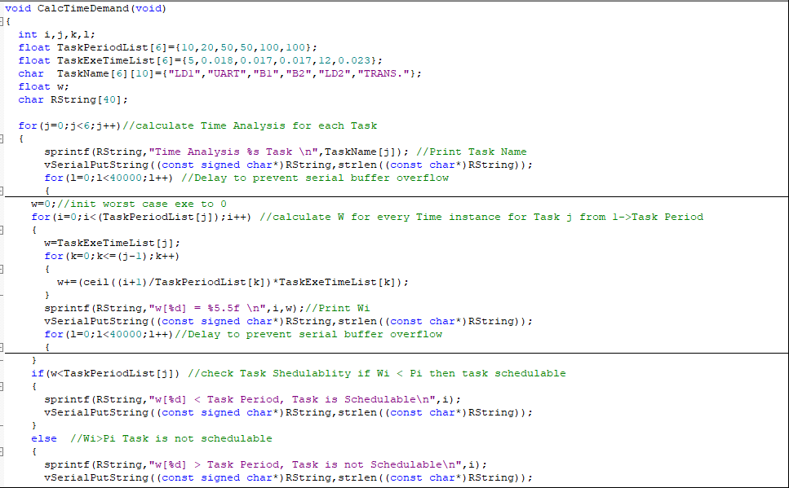

**Analysis Result**

Time Analysis LD1 Task

w[0] = 5.00000

w[1] = 5.00000

w[2] = 5.00000

w[3] = 5.00000

w[4] = 5.00000

w[5] = 5.00000

w[6] = 5.00000

w[7] = 5.00000

w[8] = 5.00000

w[9] = 5.00000

w[10] < Task Period, Task is Schedulable

Time Analysis UART Task

w[0] = 5.01800

w[1] = 5.01800

w[2] = 5.01800

w[3] = 5.01800

w[4] = 5.01800

w[5] = 5.01800

w[6] = 5.01800

w[7] = 5.01800

w[8] = 5.01800

w[9] = 5.01800

w[10] = 10.01800

w[11] = 10.01800

w[12] = 10.01800

w[13] = 10.01800

w[14] = 10.01800

w[15] = 10.01800

w[16] = 10.01800

w[17] = 10.01800

w[18] = 10.01800

w[19] = 10.01800

w[20] < Task Period, Task is Schedulable

Time Analysis B1 Task

w[0] = 5.03500

w[1] = 5.03500

w[2] = 5.03500

w[3] = 5.03500

w[4] = 5.03500

w[5] = 5.03500

w[6] = 5.03500

w[7] = 5.03500

w[8] = 5.03500

w[9] = 5.03500

w[10] = 10.03500

w[11] = 10.03500

w[12] = 10.03500

w[13] = 10.03500

w[14] = 10.03500

w[15] = 10.03500

w[16] = 10.03500

w[17] = 10.03500

w[18] = 10.03500

w[19] = 10.03500

w[20] = 15.05300

w[21] = 15.05300

w[22] = 15.05300

w[23] = 15.05300

w[24] = 15.05300

w[25] = 15.05300

w[26] = 15.05300

w[27] = 15.05300

w[28] = 15.05300

w[29] = 15.05300

w[30] = 20.05300

w[31] = 20.05300

w[32] = 20.05300

w[33] = 20.05300

w[34] = 20.05300

w[35] = 20.05300

w[36] = 20.05300

w[37] = 20.05300

w[38] = 20.05300

w[39] = 20.05300

w[40] = 25.07100

w[41] = 25.07100

w[42] = 25.07100

w[43] = 25.07100

w[44] = 25.07100

w[45] = 25.07100

w[46] = 25.07100

w[47] = 25.07100

w[48] = 25.07100

w[49] = 25.07100

w[50] < Task Period, Task is Schedulable

Time Analysis B2 Task

w[0] = 5.05200

w[1] = 5.05200

w[2] = 5.05200

w[3] = 5.05200

w[4] = 5.05200

w[5] = 5.05200

w[6] = 5.05200

w[7] = 5.05200

w[8] = 5.05200

w[9] = 5.05200

w[10] = 10.05200

w[11] = 10.05200

w[12] = 10.05200

w[13] = 10.05200

w[14] = 10.05200

w[15] = 10.05200

w[16] = 10.05200

w[17] = 10.05200

w[18] = 10.05200

w[19] = 10.05200

w[20] = 15.07000

w[21] = 15.07000

w[22] = 15.07000

w[23] = 15.07000

w[24] = 15.07000

w[25] = 15.07000

w[26] = 15.07000

w[27] = 15.07000

w[28] = 15.07000

w[29] = 15.07000

w[30] = 20.07000

w[31] = 20.07000

w[32] = 20.07000

w[33] = 20.07000

w[34] = 20.07000

w[35] = 20.07000

w[36] = 20.07000

w[37] = 20.07000

w[38] = 20.07000

w[39] = 20.07000

w[40] = 25.08800

w[41] = 25.08800

w[42] = 25.08800

w[43] = 25.08800

w[44] = 25.08800

w[45] = 25.08800

w[46] = 25.08800

w[47] = 25.08800

w[48] = 25.08800

w[49] = 25.08800

w[50] < Task Period, Task is Schedulable

Time Analysis LD2 Task

w[0] = 17.05200

w[1] = 17.05200

w[2] = 17.05200

w[3] = 17.05200

w[4] = 17.05200

w[5] = 17.05200

w[6] = 17.05200

w[7] = 17.05200

w[8] = 17.05200

w[9] = 17.05200

w[10] = 22.05200

w[11] = 22.05200

w[12] = 22.05200

w[13] = 22.05200

w[14] = 22.05200

w[15] = 22.05200

w[16] = 22.05200

w[17] = 22.05200

w[18] = 22.05200

w[19] = 22.05200

w[20] = 27.07000

w[21] = 27.07000

w[22] = 27.07000

w[23] = 27.07000

w[24] = 27.07000

w[25] = 27.07000

w[26] = 27.07000

w[27] = 27.07000

w[28] = 27.07000

w[29] = 27.07000

w[30] = 32.07000

w[31] = 32.07000

w[32] = 32.07000

w[33] = 32.07000

w[34] = 32.07000

w[35] = 32.07000

w[36] = 32.07000

w[37] = 32.07000

w[38] = 32.07000

w[39] = 32.07000

w[40] = 37.08800

w[41] = 37.08800

w[42] = 37.08800

w[43] = 37.08800

w[44] = 37.08800

w[45] = 37.08800

w[46] = 37.08800

w[47] = 37.08800

w[48] = 37.08800

w[49] = 37.08800

w[50] = 42.12200

w[51] = 42.12200

w[52] = 42.12200

w[53] = 42.12200

w[54] = 42.12200

w[55] = 42.12200

w[56] = 42.12200

w[57] = 42.12200

w[58] = 42.12200

w[59] = 42.12200

w[60] = 47.14000

w[61] = 47.14000

w[62] = 47.14000

w[63] = 47.14000

w[64] = 47.14000

w[65] = 47.14000

w[66] = 47.14000

w[67] = 47.14000

w[68] = 47.14000

w[69] = 47.14000

w[70] = 52.14000

w[71] = 52.14000

w[72] = 52.14000

w[73] = 52.14000

w[74] = 52.14000

w[75] = 52.14000

w[76] = 52.14000

w[77] = 52.14000

w[78] = 52.14000

w[79] = 52.14000

w[80] = 57.15800

w[81] = 57.15800

w[82] = 57.15800

w[83] = 57.15800

w[84] = 57.15800

w[85] = 57.15800

w[86] = 57.15800

w[87] = 57.15800

w[88] = 57.15800

w[89] = 57.15800

w[90] = 62.15800

w[91] = 62.15800

w[92] = 62.15800

w[93] = 62.15800

w[94] = 62.15800

w[95] = 62.15800

w[96] = 62.15800

w[97] = 62.15800

w[98] = 62.15800

w[99] = 62.15800

w[100] < Task Period, Task is Schedulable

Time Analysis TRANS. Task

w[0] = 17.07500

w[1] = 17.07500

w[2] = 17.07500

w[3] = 17.07500

w[4] = 17.07500

w[5] = 17.07500

w[6] = 17.07500

w[7] = 17.07500

w[8] = 17.07500

w[9] = 17.07500

w[10] = 22.07500

w[11] = 22.07500

w[12] = 22.07500

w[13] = 22.07500

w[14] = 22.07500

w[15] = 22.07500

w[16] = 22.07500

w[17] = 22.07500

w[18] = 22.07500

w[19] = 22.07500

w[20] = 27.09300

w[21] = 27.09300

w[22] = 27.09300

w[23] = 27.09300

w[24] = 27.09300

w[25] = 27.09300

w[26] = 27.09300

w[27] = 27.09300

w[28] = 27.09300

w[29] = 27.09300

w[30] = 32.09300

w[31] = 32.09300

w[32] = 32.09300

w[33] = 32.09300

w[34] = 32.09300

w[35] = 32.09300

w[36] = 32.09300

w[37] = 32.09300

w[38] = 32.09300

w[39] = 32.09300

w[40] = 37.11100

w[41] = 37.11100

w[42] = 37.11100

w[43] = 37.11100

w[44] = 37.11100

w[45] = 37.11100

w[46] = 37.11100

w[47] = 37.11100

w[48] = 37.11100

w[49] = 37.11100

w[50] = 42.14500

w[51] = 42.14500

w[52] = 42.14500

w[53] = 42.14500

w[54] = 42.14500

w[55] = 42.14500

w[56] = 42.14500

w[57] = 42.14500

w[58] = 42.14500

w[59] = 42.14500

w[60] = 47.16300

w[61] = 47.16300

w[62] = 47.16300

w[63] = 47.16300

w[64] = 47.16300

w[65] = 47.16300

w[66] = 47.16300

w[67] = 47.16300

w[68] = 47.16300

w[69] = 47.16300

w[70] = 52.16300

w[71] = 52.16300

w[72] = 52.16300

w[73] = 52.16300

w[74] = 52.16300

w[75] = 52.16300

w[76] = 52.16300

w[77] = 52.16300

w[78] = 52.16300

w[79] = 52.16300

w[80] = 57.18100

w[81] = 57.18100

w[82] = 57.18100

w[83] = 57.18100

w[84] = 57.18100

w[85] = 57.18100

w[86] = 57.18100

w[87] = 57.18100

w[88] = 57.18100

w[89] = 57.18100

w[90] = 62.18100

w[91] = 62.18100

w[92] = 62.18100

w[93] = 62.18100

w[94] = 62.18100

w[95] = 62.18100

w[96] = 62.18100

w[97] = 62.18100

w[98] = 62.18100

w[99] = 62.18100

w[100] < Task Period, Task is Schedulable

**Summary:**

Time Analysis result for Given Task set , System is scheduable.

# System validation using Simso offline simulator

## USING EDF Scheduler

* Results

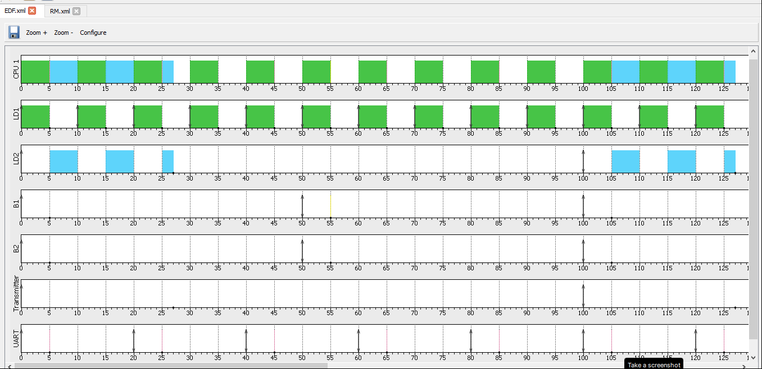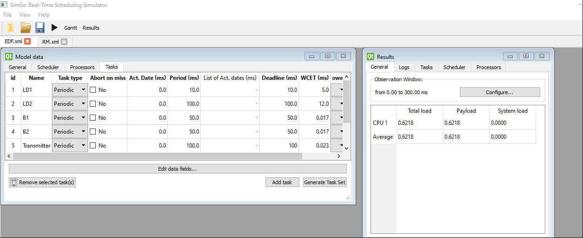

* Gantt chart

## using Rm scheduler

* Results

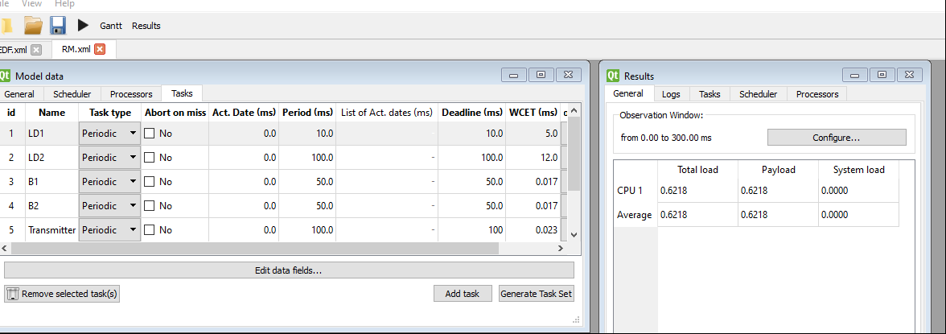

* Gantt chart

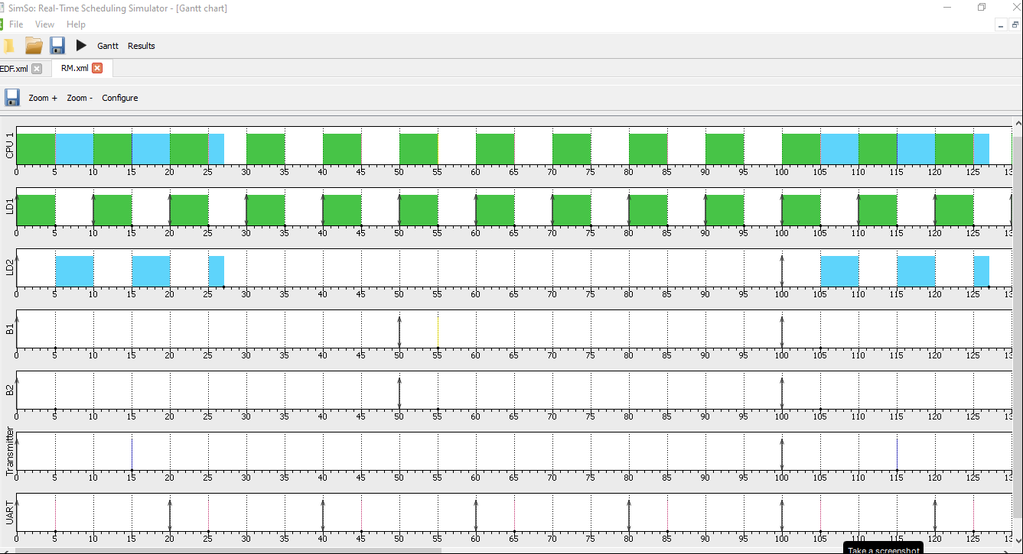

* Log

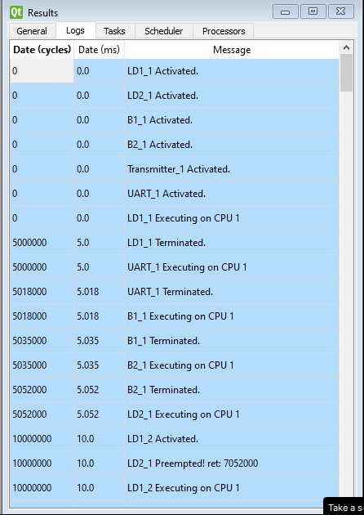

## Calculation of CPU load USING KEIL Sim. (timer1,trace macros)

CPU_Usage=((LD1_TotalTime+LD2_TotalTime+B1_TotalTime+B2_TotalTime+Trans_TotalTime+UART_TotalTime)/(float)TotalTime)*100 =62.44%

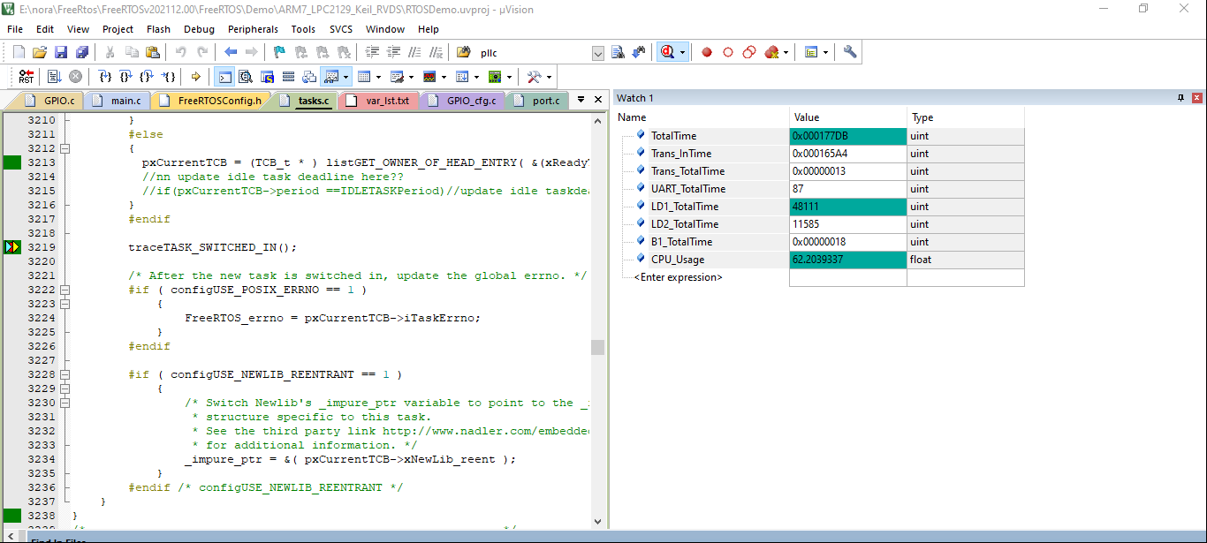

TOTAL SYSTEM TRACE USING KEIL SIM(TIMER1,GPIO,Trace macros)

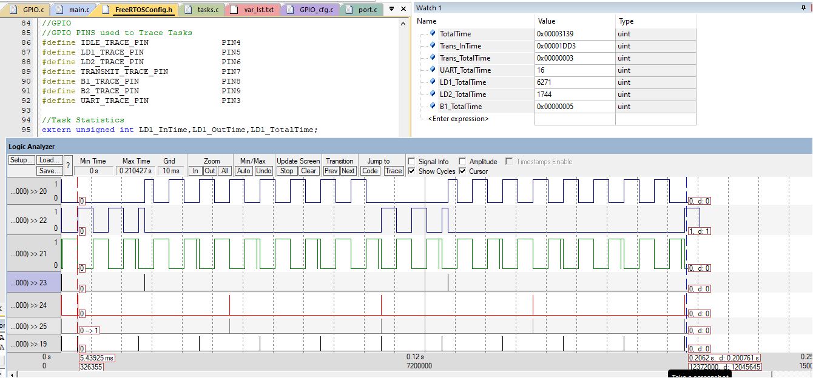

# Notes

## immplementation

Comparing Task Trace to Simso output for EDF I found results have identical task activation sequence .

Only when two tasks with same deadline become active together result may differ since any task can be chosen Randomly(as stated in EDF assumptions)

In the given Task set case: LD2 Task , Transmitter Task since they both same Deadline.

## results

System with given Task set was proved to be schedulable by both scheduling techniques: RM, EDF.

## Extra system Modifcations Note

Extra changes were needed to complete EDF implementation:

* Problem: (In “prvAddNewTaskToReadyList ()”)

After Task creation a check for created task priority against current task priority if created task priority is equal or higher than current task make created task current task.

Since all tasks were created with same priority, the above condition resulted on last created task to run first though it is not the one having least deadline.

Solution:

Check if using EDF(i.e. configUSE_EDF_SCHEDULER==1) then get head of EDFReadyList instead of checking priorty.

* Made IdleTask Deadline with Macro define ” IDLE_TASK_DL” and chose value 150 (to be larger than farst task deadline in system).
* Updated Idle Task deadline every tick ,in “ xTaskIncrementTick()”

Another better place is at “vTaskSwitchContext()” if switch is to Idle task .

* In validation stage call for set task tag should be done directly after task creation not at task start

To ensure intial task startup is plotted.

* GPIO PINs 10🡪16 are used for uart1 so we can not use them in Task Trace with GPIO.

Egypt FWD 2022

Advanced Embedded   
Track  
RTOS Project